Digi Locker Work Flow
1.A Citizen Login Page
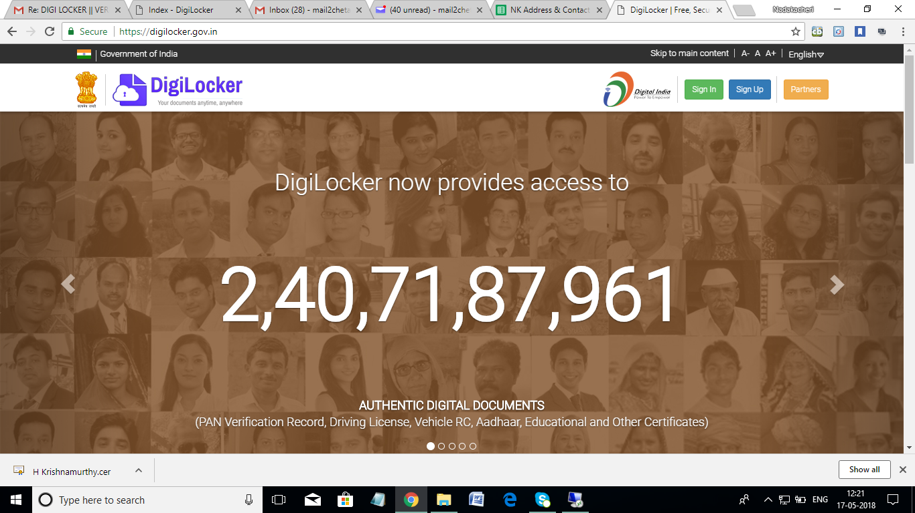

2. A citizen can log in either through the registered digiloker credentials or by Aadhar based OTP verification
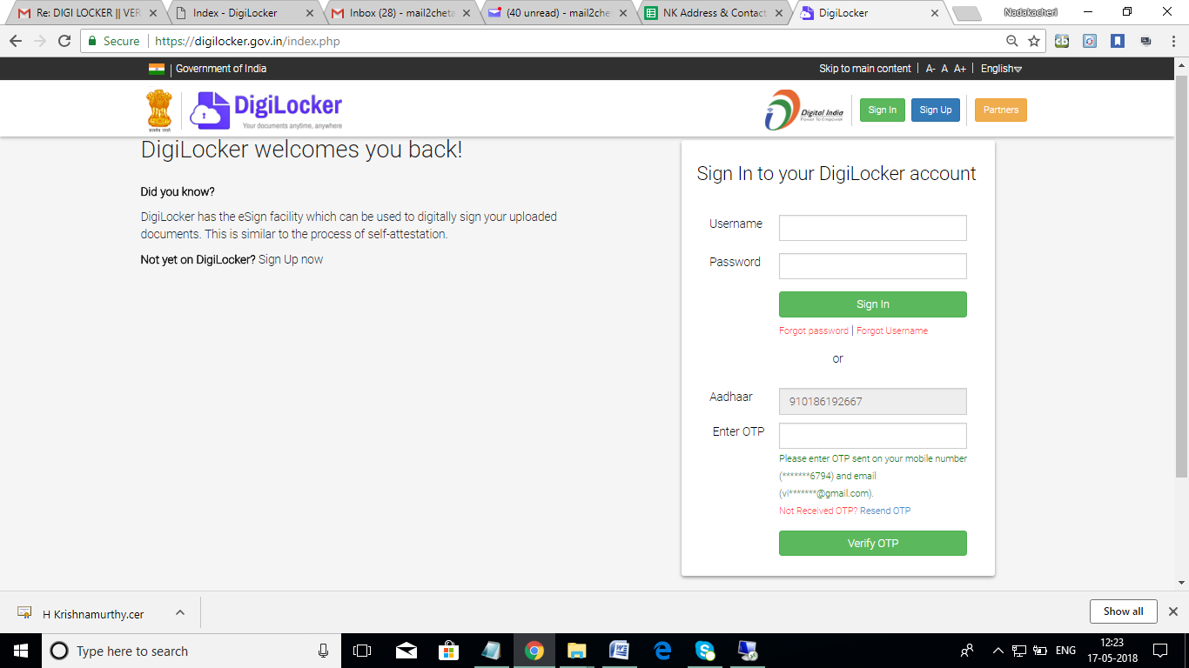
3. Citizen Login Dashboard view.
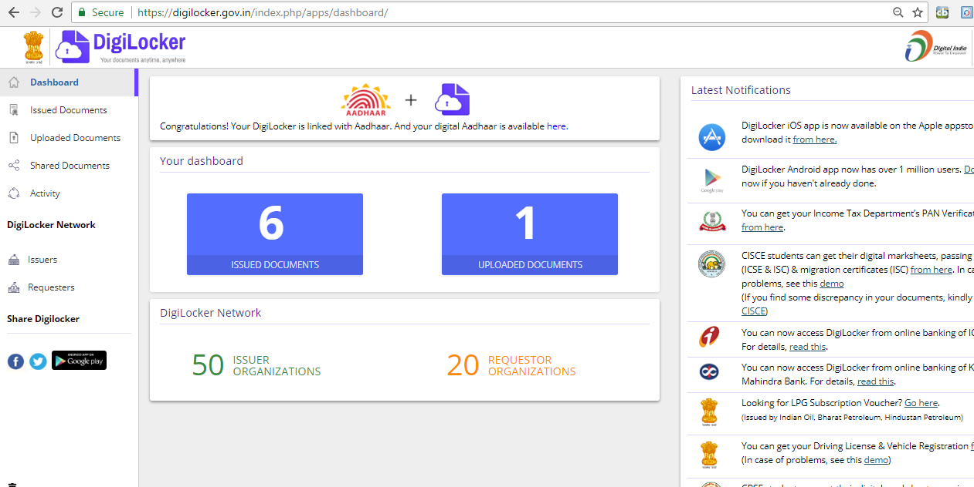

4. To request Certificate into your digi locker click on HERE hyperlink in Dashboard.

5. Issued documents will be displayed, If you wish to request any documents from partner pls click on check partner section hyperlink
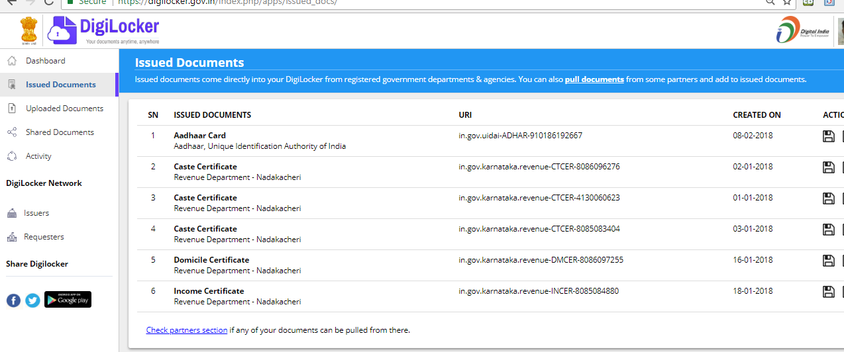
6. Select partner name as- Revenue Department- Nadakacheri, Karnataka, and service as per the need.
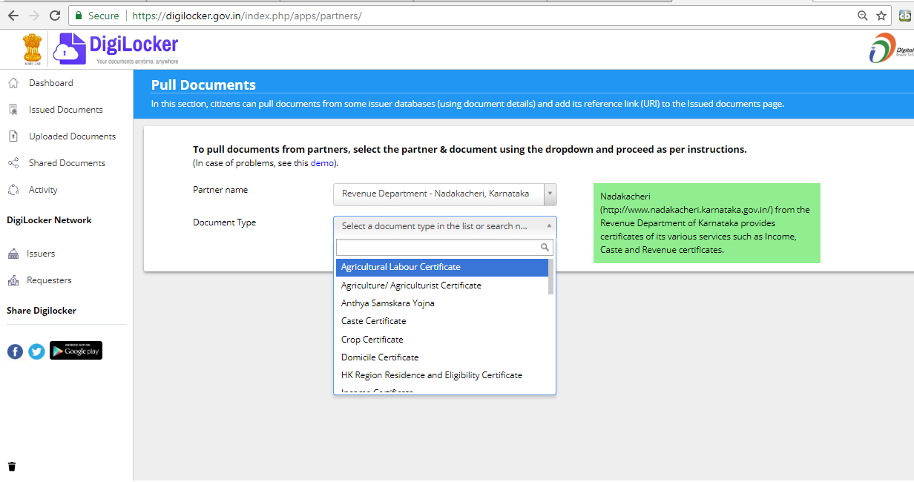

7. After selection of respective service, pls enter the Valid GSC ( Ack ) Number. And click on the accept checkbox.
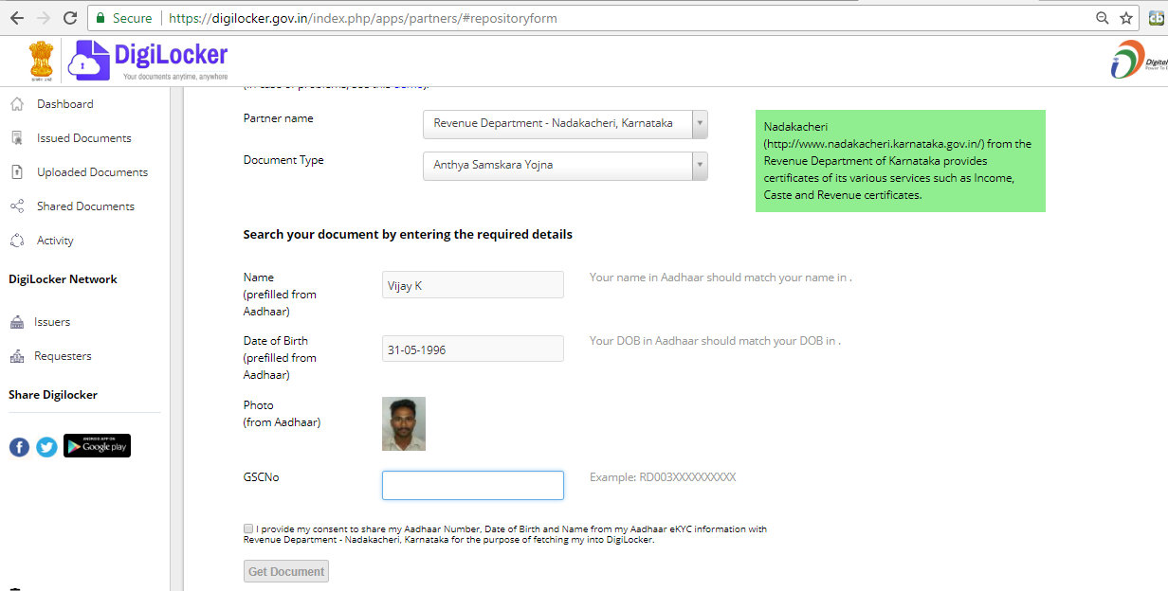

8. Click on Get Document
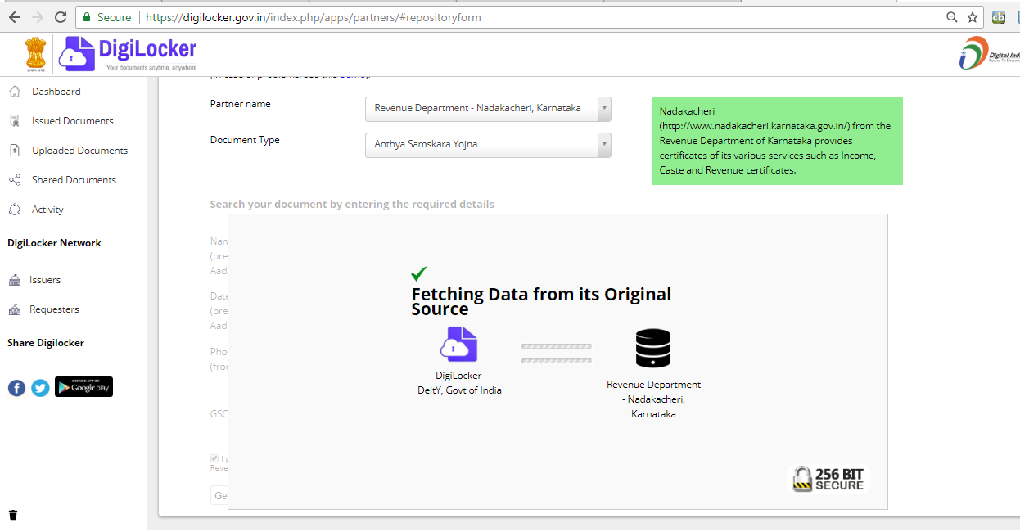
9. If applicant Name and Aadhar Name doesn’t match and name percentage is less than 80% then it will go to respective DT login. If it matches more than 80% citizen will get certificate immediately in the login.

10. If Name match less than 80%. Login to respective DT login
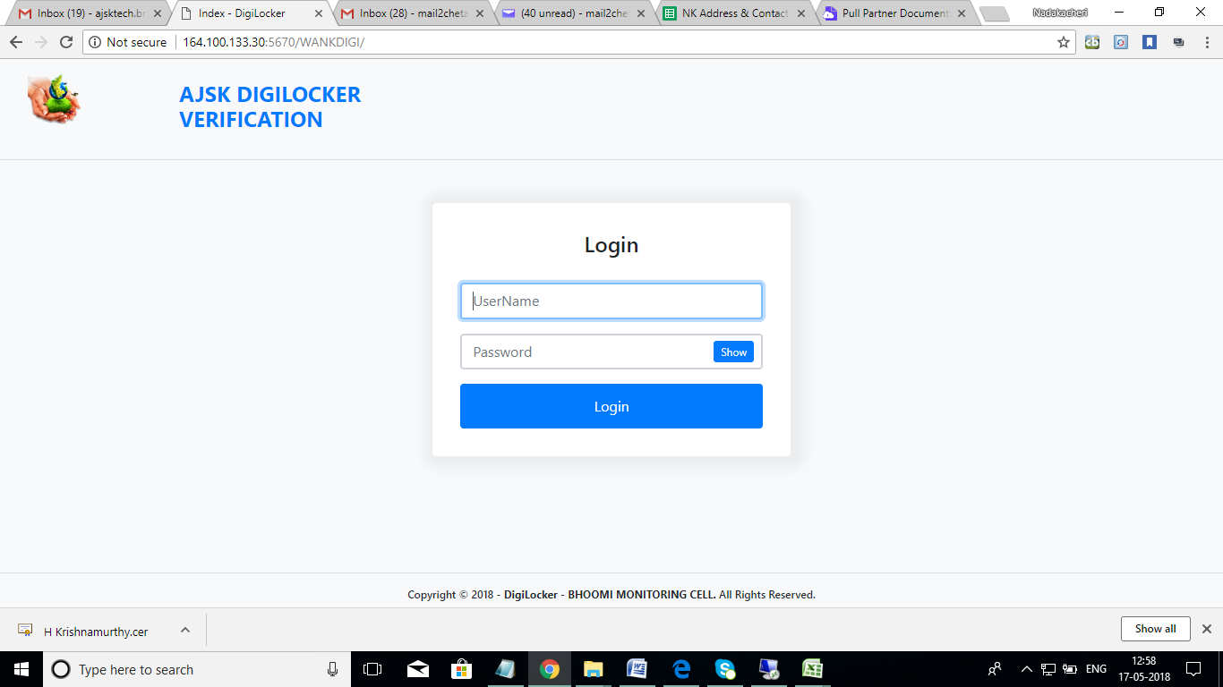

11. DT can approve/ Reject.
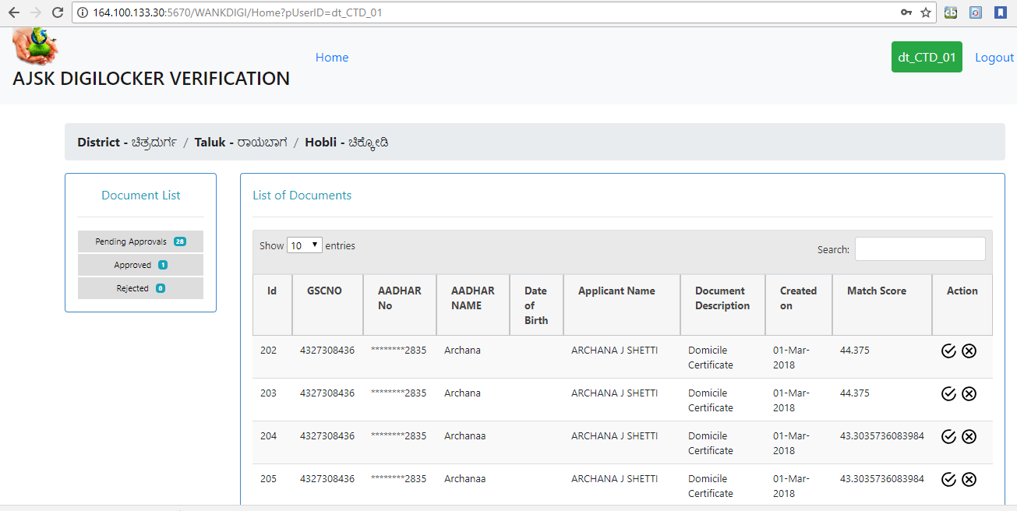
If DT wants to approve, Click on .
If DT wants to Reject, Click on
12. In Document List, DT can view Pending Approvals, Approved and Rejected.
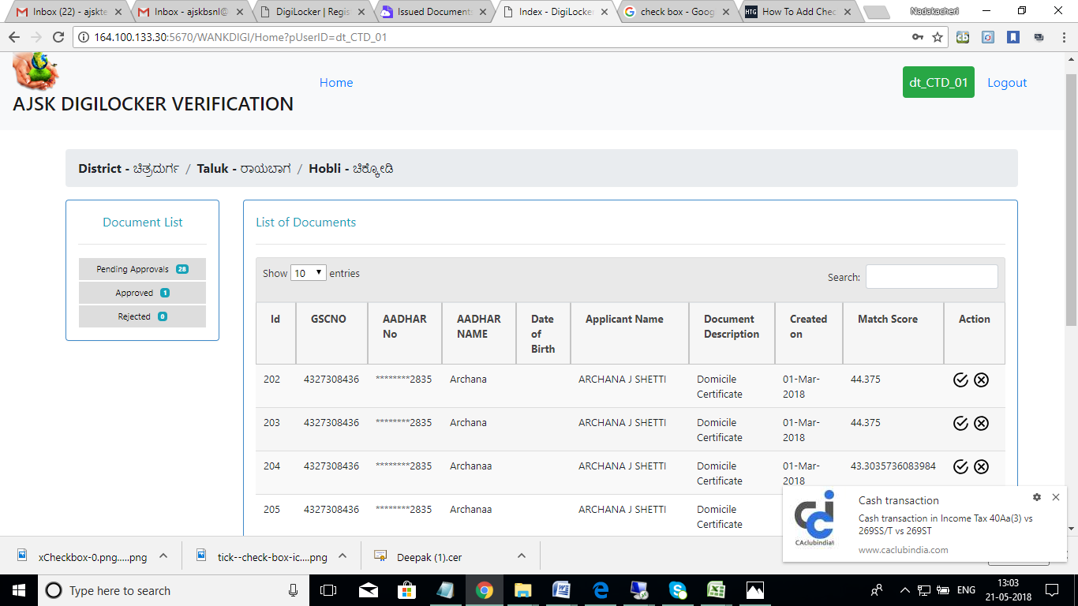

DIGILOCKER WORKFLOW DIAGRAM

Digilocker Login

Request for Certificate in Citizen Login in Digi locker

If requested Certificate > 80% of match result

YES

NO

NO
Goes to DT login.
DT is having two options
Approve Request
Reject Request

Approved Rejected

If rejected no certificate will be allowed to download or transferred “an intimation msg shall be sent”” (yet to be incorporated)
The requested service certificate will available in digi locker login in PDF to download

